IOT BASED INDUSTRIAL MONITORING SYSTEM

ABSTRACT

The Internet of Things (IOT) is a new sector that aims to connect "things," "people," and "machines" to the internet. Modernization and automation are sweeping the globe, with IOT-based industrial monitoring solutions at the forefront. The importance of assessing the state of the industry is vital to the safety and efficiency of the products. The goal of this study is to create an IOT-based industrial monitoring system with intelligent sensors. Because of the integration of big data, the Blynk app can be used to monitor status from anywhere on the planet. Data analysis has been streamlined, allowing for easier IOT monitoring. The proposed technology could be beneficial to manufacturing industries. Adding technology to any kind of manufacturing industry will assure the safety and well-being of the people as well as prevent accidents. Using automation technology reduces the chances of loss and accidents in the machinery world.

INTRODUCTION

Technology advancement is a never-ending process; thus, we must be well-equipped and informed about new developments. Day-to-Day human life has gotten more convenient as a result of these technological improvements. Automation has evolved into a must need. The internet today provides access to all data and systems, and web technology is continually expanding. A network interface enables remote management and control of embedded devices using a web-based embedded system. Controlling Internet of Things (IoT) device is done through web controllers, often known as E-controllers. A web controller, often known as an E- controller, is a set of embedded systems and software stacks that is the most extensively used method of web development in the world. Instead of employing large server systems for monitoring, administering, and handling data, remote login and monitoring using a distributed web control system produced using web pages generated in web applications are increasingly used instead of big server systems for monitoring, administering, and processing data. Web control systems that leverage IOT has three characteristics: energy savings, comfort, and efficiency. Our main objective is to adapt the Internet control system to the Internet of Things, allowing users to access the application over the Internet from anywhere in the globe. IOT monitoring allows you to analyze dynamic systems and analyze billions of events and alerts. IOT monitoring also enables you to bridge the gap between devices and businesses by collecting and analyzing a wide range of IOT data at a web scale across connected devices, consumers, and apps. The industrial monitoring system connects itself with the open-source app Blynk. Blynk connects itself with esp8266 for virtual control of the devices along with getting updates. The Arduino Mega is the brain of the project connected to the component and operates them with the code embedded in it. Sensors like smoke sensors, humidity, and temperature sensors are used to monitor the surroundings of the machine.

METHODOLOGY

The Industrial Monitoring System project is built on the Internet of Things (IOT). Arduino is used to control various sensors (using smoke and temperature sensors) providing complete control over the industry. The Internet of Things (IOT) is used in this project to deliver data to the user. The Internet of Things (IOT) is a network of 'things' that allows physical items to communicate data by using sensors, electronics, software, and networking. These systems are self-contained and do not need to interact with humans .

The system feeds signals from several sensors, such as the smoke, temperature, and humidity sensors, to the Arduino Mega microcontroller. The data is subsequently sent to the IT module via the microcontroller (ESP8266). The ESP8266 is a chip that allows microcontrollers to connect to a Wi-Fi network, establish TCP/IP connections, and deliver data. In case a fire takes place, the smoke sensor and the temperature sensor would detect the presence of smoke and temperature changes and send the information to the Arduino. The information then is transmitted through ESP8266 to the Blynk app. Blynk app is a free app on the play store where you can connect your IOT module to your phone screen, and helps you control the project and its activities virtually. The IOT module, four LEDs, one fan, and an LCD are all connected to the microcontroller. LEDs represent different pieces of machinery that can be as a symbol.

The temperature and humidity values are also displayed on the Blynk app, thanks to Arduino and the internet. At the same time, informative messages would be displayed on the LCD for manual control. The Wi-Fi module must be linked to a Wi-Fi zone as a pre-requisite for this project. This project can as well be implemented using the GSM module instead of the IOT module. Instead of the Blynk app, you can also create your app through MIT app invector as well.

COMPONENTS

* Arduino Mega,
* WIFI Module (ESP8266),
* Smoke sensor(MQ-2),
* Temperature and Humidity sensor,
* LCD Display,
* Watt LED,
* Blynk

Arduino Meg

The Mega 2560 is a microcontroller board that uses the ATmega2560 microcontroller. It contains 54 digital input/output pins (with 15 of them capable of being used as PWM outputs), 16 analog inputs, 4 UARTs (hardware serial ports), a 16 MHz crystal oscillator, a USB connection, a power jack, an ICSP header, and a reset button.

To get started, simply connect it to a computer with a USB wire or power it using an AC-to-DC adapter or battery. The Mega 2560 board is compatible with most Uno shields.

The operating voltage is 5V, with a suggested input voltage of 7-12V and a maximum input voltage of 6-20V. The Arduino Mega 2560 is programmed using the Arduino Software (IDE), which is the same for all boards and can be used both online and offline

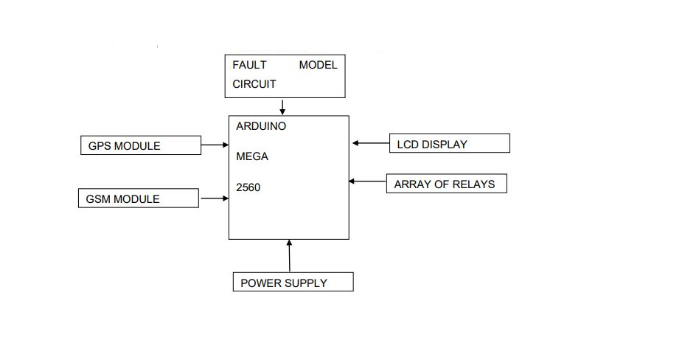

Block diagram of Arduino Meg

WIFI Module (ESP8266)

The signal from several sensors is sent to the microcontroller ESP8266 by an IOT-based industrial monitoring and fault detection system. The data is then sent over the internet via the microcontroller. The ESP8266 is a Wi-Fi-capable microcontroller. It has 4MB of flash memory, an 80 MHz system clock, 64 KB of SRAM, and an on-chip Wi-Fi transceiver.

Smoke sensor(MQ-2)

The smoke sensor is based on the free scale semiconductor MC145012DW smoke detector chip. The IC is made comprised of an infrared photoelectric chamber. The relay will fire in approximately 20 seconds after it senses dispersed light from minute smoke particles. The MQ-2 smoke sensor detects smoke and combustible gases such as LPG, Butane, Propane, Methane, Alcohol, and Hydrogen. The sensor's resistance varies based on the gas type. The smoke sensor features a built-in potentiometer that allows you to change the sensitivity of the sensor depending on how precise you want the gas detection to be. The sensor's output voltage varies in response to the amount of smoke or gas present in the air. The sensor produces a voltage that is proportionate to the amount of smoke/gas present. The MQ-2 sensor has four pins: analog pins, digital pins, GND, and VCC-5V.

Temperature and Humidity sensor

The temperature range of the DHT11 is 0 to 50 degrees Celsius with a +-2 degree accuracy, and the humidity range is 20 to 80 % with a 5% accuracy. Sensors operate at 3 to 5 volts, with a maximum current of 2.5 milliamperes when measuring. Temperature sensors are often used to monitor heat or temperature in industrial operations in hazardous areas. Humidity sensor: Measuring both moisture and temperature in the air and presenting relative humidity as a percentage, this sensor effectively monitors relative humidity in the surroundings. Moisture from the air settles on the film, causing variations in the voltage levels between the two plates, which are then translated to digital data.

LCD Display

An LCD (Liquid Crystal Display) screen is an electronic display module and has a wide range of applications. A 16x2 LCD is a relatively basic module that is applied in a wide range of devices and circuits. A 16x2 LCD can display 16 characters per line on two lines. Each character is represented by a 5x7 pixel matrix on this LCD. There are two registers on this LCD: Command and Data. This display's working voltage varies from 4.7V to 5.3V. The display bezel measures 72 x 25mm, and the operating current without a backlight is 1mA. The HD47780 controller's PCB measures 80L x 36W x 10H mm, while the module's PCB measures 80L x 36W x 10Hmm. Green or blue LED backlights are available. The number of columns – 16, Number of rows – 2, Number of LCD pins – 16, Characters – 32, It works in 4-bit and 8-bit modes. The pixel box of each character is 5×8 pixel Font size of a character is 0.125Width x 0.200height.

Block Diagram of LED Display:

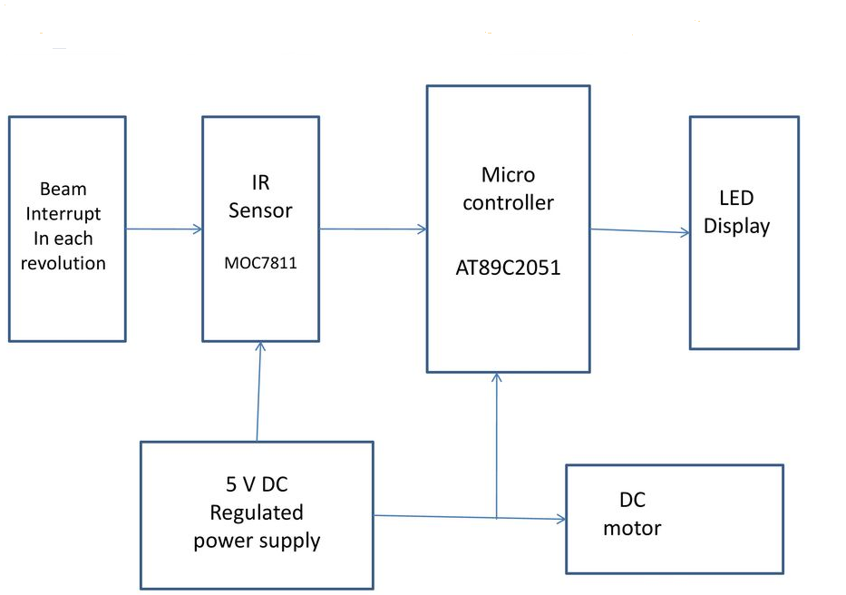

Watt LED

A 1 WATT LED (Light Emitting Diode) has two terminals, just like any other LED. The first is the positive terminal, whereas the second is the negative terminal. Current via LED (Light Emitting Diode): 300mA to 350mA, the voltage applied between anode to cathode 3.0 V to 3.5 V (Typical Operating Voltage: 3.3 V), the voltage applied between anode and cathode: 3.0 V to 3.5 V (Typical Operating Voltage: 3.3 V) (350mA being absolute maximum forward current allowed through the LED). There are numerous advantages to using LEDs, includding improved power handling, energy savings, and longer-lasting.

Block Diagram of Watt LED

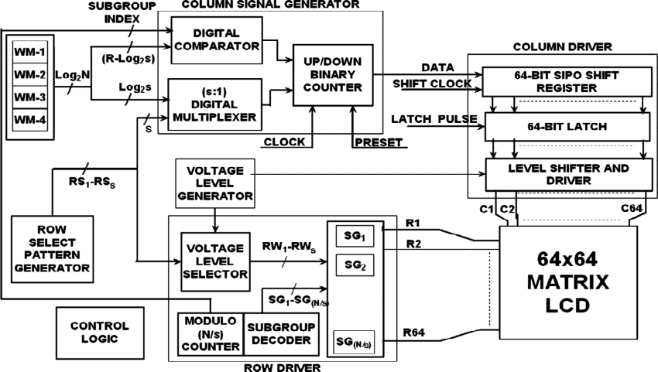

**Blynk**

Blynk was created with the Internet of Things in mind. It can manage hardware remotely, show sensor data, and store data. Blynk was created with the Internet of Things in mind. It can manage hardware remotely, show sensor data, and store data. Blynk is a web-based service. This implies that the gear you select must be capable of connecting to the internet. Some of the boards, such as the Arduino Board, will require an Ethernet or Wi-Fi Shield to interact, while others, such as the ESP8266 and the Raspberri Pi with WiFi dongle, are already Internet-ready. Blynk Server is in charge of all data transfers between the smartphone and the hardware. It's open-source, capable of supporting thousands of devices, and can even run on a Raspberry Pi. Blynk Libraries are for everyone. Blynk Libraries enable communication with the server and process all incoming and outgoing commands for all popular hardware platforms. Blynk was created with the internet of things applications in mind. It successfully controls hardware remotely and shows sensor data on Android mobiles. The following are the components of the Blynk platform: Toolkit for Blynk applications: This allows you to build projects using the control panel's numerous widgets. Blynk server: A server that links a smartphone to hardware through Wi-Fi or Bluetooth. The Blynk server is open source and capable of supporting thousands of devices. Blynk libraries: Supports all common embedded systems and allows communication with the server as well as the processing of all commands.

DESIGN IMPLEMENTATION

The design of the project is projected. In the figure, the Arduino Mega is the microcontroller that sets the commands for all other devices connected to it. Arduino mega takes input from DHT11 (humidity and temperature sensor) and MQ-2(smoke sensor) and gives output on the screen of Lcd. Other electronics components like the led bulbs for the place of devices are used to represent different machines in the industry. There is a motor to moderate the heat of the industry. The power supply is given is9V to the Arduino. The supply can be given by a battery or by the adaptor. In another way, by adding a stepdown transformer, a direct connection to the switchboard can be made. Then a wifi module (ESp8266) is connected for internet communication to the Blynk app. In the Blynk app, referring to Figure 2 4 buttons for led devices are placed on- screen with the names LED1, LED2, LED3, and LED4 buttons named as D4, D5, D6 andD7. There are 3 gauges for gas, humidity, and temperature. Buttons will control the working of the LED device and the gauge will show the status of the sensors. Along with that on LCD the details will be described.

DESIGN IMPLEMENTATION Block Diagram:

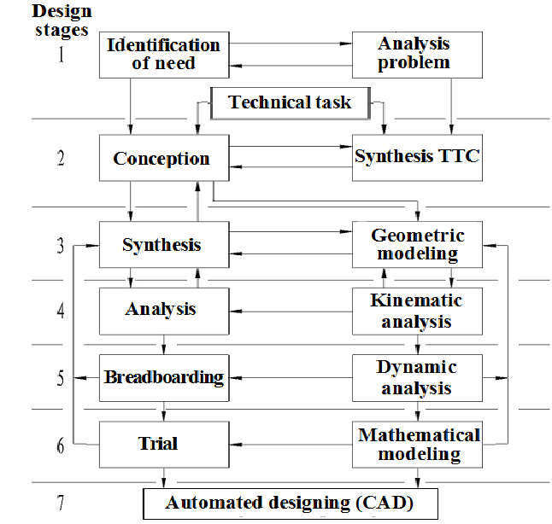

The flow of programming written can be understood. The application was written in the C++language using the Arduino IDE.

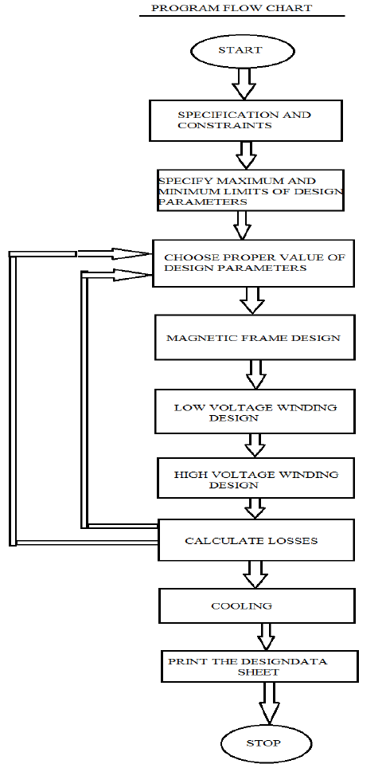

RESULTS AND DISCUSSION

The IoT-based study can be enhanced further by offering extra functionality to industry personnel through the use of an Android app to improve industry control and monitoring. Smoke and gas sensors can also be connected to the system to safeguard the safety of workers and commodities in the event of a fire or poisonous gas leak. Data can be used to minimise industrial dangers in high-profile factories, track yield in power plants, assure safety in fast-paced industries, and assess nuclear safety levels, among other things. Time can be saved if the info is delivered quickly. For reliable damage and fault detection, real-time monitoring system based on physical model are required.

CONCLUSION

We hope to gain hands-on experience with the trending technologies of "Embedded System" and "Internet of Things" through this project. IoT-enabled industrial monitoring systems have become increasingly popular in a variety of industries because they improve safety standards by providing real-time monitoring of critical parameters such as temperature, humidity, and smoke, as well as alerting officials and workers regularly. The implementation is not only for safety reasons, but it also has the potential to increase industry yields. In our project, the Internet of Things (IoT) is used to collect data and communicate through the internet. We hope that our project will be beneficial enough to be implemented in industries across India, saving lives and property from accidents and risks that are often overlooked by industry personnel and users. Companies in the industrial and logistics sectors can better meet the new era of instant needs by utilizing the Industrial Internet of Things (IoT). IoT technologies are used in manufacturing processes and across supply chains in the Industrial Internet of Things.